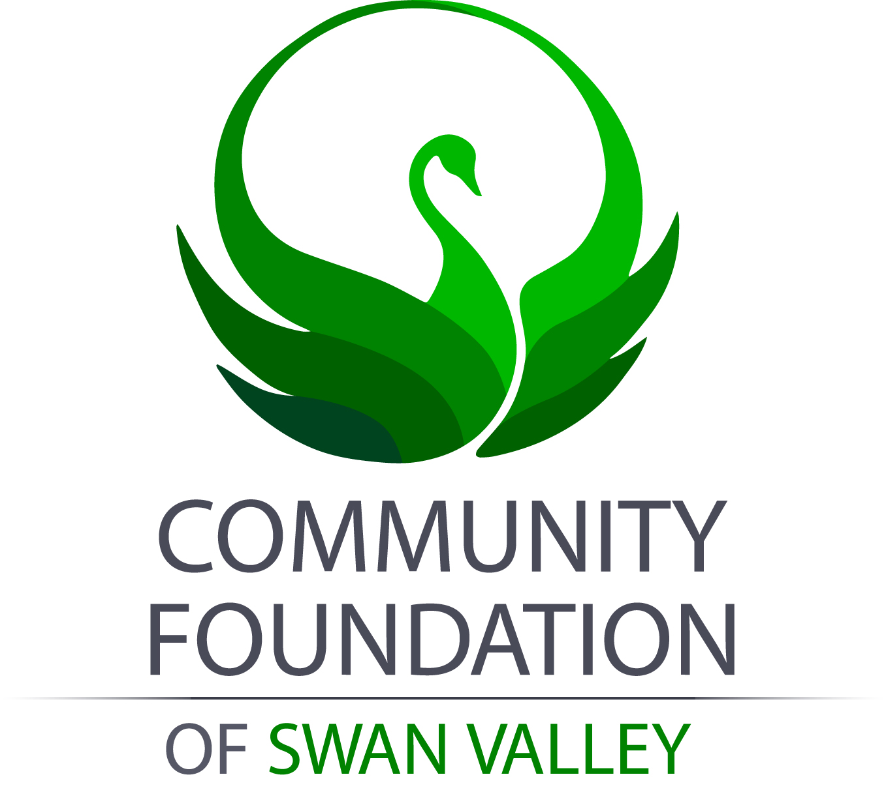
COMMUNITY FOUNDATION OF SWAN VALLEY INC.
P. O. BOX 1509
SWAN RIVER MB ROL 1ZO
204-734-9129

“Cherban Endowment Post-Secondary Scholarship”

The Cherban Post-Secondary Scholarship was created and awarded for the first time in 2019. The fund originated due to a generous donation from the Department of Agriculture and the Estate of Alexander and Marvin Cherban. The Cherban’s were twin brothers who farmed for many years in the Birch River-Lenswood area. It was their wish that the proceeds from their estate would foster and promote the advancement of agricultural excellence in the Swan River Valley. The interest from this fund will assist students pursuing studies in the field of agricultural related programs for years to come.

The Community Foundation of Swan Valley manages this award. The Academic Awards Committee will select the award recipient and notify them by the end of Oct of each year. The initial value of this scholarship is $1,500, future awards will be determined by the interest from the Fund. The Award will be paid in early December directly to a qualified educational institution and applied to the student’s winter term tuition. Additional eligibility requirements are listed below.

Summary of Award Requirements:

1. The student shall be a recent Grade 12 graduate of the Swan Valley Regional Secondary School; proof of graduation will be required (copy of high school transcript).
2. The Student shall be entering a College or University to complete a Diploma or Degree Program in the field Agriculture, or a field related to Agriculture (preference will be given to Canadian Institutions).

3. Should the student be completing a prerequisite year prior to being accepted into an agricultural program, funds can be held for up to one year until they are accepted into the program.

4. In any given year, if multiple students are eligible for this award, students with average academic achievement, greatest financial need and extensive agricultural family background should be selected.

5. Initial award is $1,500, subsequent awards to be determined by the interest from the fund.

To apply, print and complete the attached application form, scan and e-mail or mail all required items to the Community Foundation of Swan Valley at cfswanvalley@gmail.com by midnight Oct 1 (or midnight first weekday of Oct). If submitting documents by mail, they must be clearly post-marked by the Oct deadline. CFSV is not responsible for delays in electronic transmission.

Have you included: 1. Completed application 2. Copy of resume 3. Copy of proof of enrollment

COMMUNITY FOUNDATION
OF SWAN VALLEY INC.
BOX 1509
SWAN RIVER MB ROL 1ZO
204-734-9129

“Cherban Endowment Post-Secondary Scholarship”

DATE:

NAME: ________________ LAST FIRST MIDDLE

CURRENT ADDRESS: __________________________ City Prov. Postal Code

PERMANENT ADDRESS: ________________ City Prov. Postal Code

E-mail Address: ___________ HOME PHONE: __ CELL PHONE: _____

SINGLE MARRIED DEPENDENTS: YES NO IF YES, # OF DEPENDENTS __________

Current Status: (check one) Undergraduate Graduate Major _____________________________

Will you be a full-time student (12-15 cr. hrs.) during the school term? Yes No

Will you be working during the school term? Yes No

Will you be applying for other financial assistance or student loans? Yes No

EMPLOYMENT RECORD

Dates Position (most recent, first) Employer
__________________ ___________________________________________ ___________________________________

__________________ ___________________________________________ ___________________________________

__________________ ___________________________________________ ___________________________________

IMPORTANT: PRINT OR TYPE FORM LEGIBLY AND COMPLETELY. APPLICATIONS WILL NOT BE CONSIDERED IF THEY ARE INCOMPLETE OR ILLEGIBLE.

